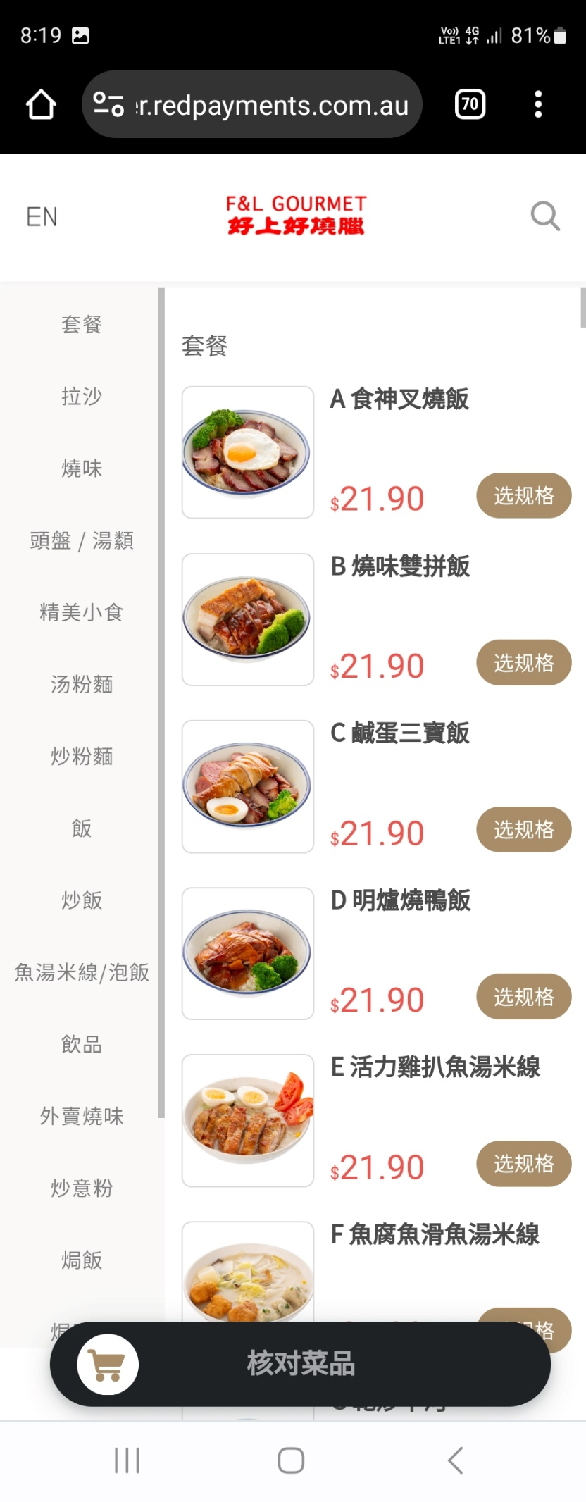

**Computer browser view:**



